**Questions:=>**

**1.When to use SQL over NOSQL?what are the usecases of sql and nosql**.=>

-the SQL and NoSQL depends on your requirements, saying that NoSQL is not secure is not accurate, this is like saying that SQL is not scalable... which is not true either.

-NoSQL [does not](http://blogs.shephertz.com/2013/06/20/a-developers-dilemma-when-to-use-nosql/#) always promise the ACID properties, which is Atomicity, Consistency, Isolation, Durability, of the transactions.

-Therefore ,to conclude,we can say that when, from the data, when we do not expect any ACID properties from the database,then we choose Nosql.

- Few more parameters, Transactions, Schema, Data Quality, frequency of Read/ Write Operations, etc

* But there is trade off like reading speed is increased but in contrast updating inserting and deleting speed is compromised
* Finally, in era of micro services architecture on server side apps, we have database per service (not dedicated physical I mean, but logically a db per service). So it is straightforward to have two databases; a MongoDB and a Relational. Use relational for transactional stuff which will be barely 10% of use cases. Use MongoDB for the remainder use cases like, browsing data, images, reading reviews, content, accounts history etc etc. So since most uses cases over 90%+ will be MongoDB based, so still achieve the goal of high scalability.
* When you need more security with the data or more privacy with the data then relational database is the best choice
* In scenario of making payments, transferring money between accounts, stock market transactions, we need strict ACID. Even simple things like, I want to read my account balance ($100) and withdraw $90, but before I can withdraw, my wife withdraws $80. So bank ends up with negative balance in my account which probably violates some rule that bank disallows negative balance.
* So what do we do about this? Relational databases provide excellent ACID and database locking tools. One can hack around in MongoDB too, but hack is still a hack. MongoDB is coming up with ACID etc, but in a distributed shards based system with no strong consistency, I would stay away from it.

=>**1.1.when to use mysql and when to use postgresql and oracle?**=>If you’re developing an application with a database back end, which of the two should you use? Consider PostgreSQL for any application that might grow to enterprise scope, with complex queries and frequent write operations. If you’re new to the world of databases and don’t expect your application to scale up, or you’re looking for a quick tool for prototyping, then consider MySQL.

(**There is also much questions in Mysql vs Mariadb,which are apparently closely attached as the founder of both are same,but nowadays Mariadb is mostly used,before Mysql was used the most.**)

Companies using Which databases

1)Airbnb-Mysql

2)Uber=Nosql(cassandra),Mysql

3)Dropbox=Mysql

4)Pinterest=Mysql

5)Facebook=Cassandra

6)Udemy=Mysql

7)Spotify=Postgresql

8)Instagram=Postgresql and cassandra

9)Paypal=Oracle,Mysql

10)Netflix=Postgresql,Mysql,Cassandra,Dynamodb,Oracle,RDS,atlas-db

11)Google=Bigtable(Nosql),Mysql

12)Stripe=Postgresql

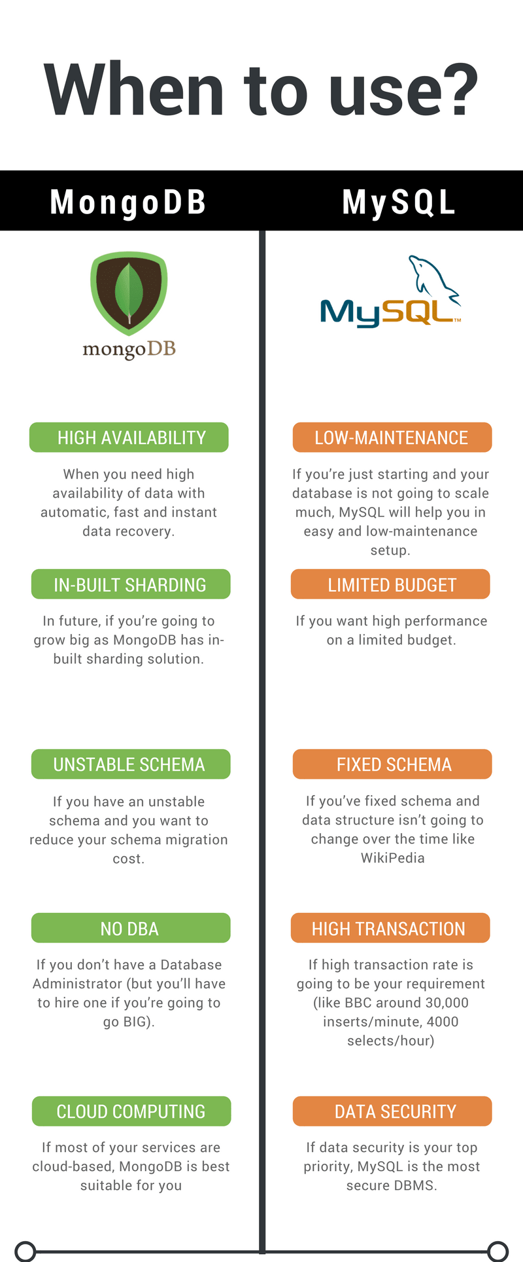

-in NOsql ,we can’t do join or maintain relationship,so think about this before choosing.

-MongoDB (and most other NoSQL databases) do not natively support the concept of relations. RDBMSs have native query tools to define and make use of relationships (JOINs, for example) that MongoDB lacks.

**2.When to use Apache kafka over rabbitmq or vice versa?What are the use cases of both?=>**

**3.When is Elasticsearch is utilised in system and why to use Elasticsearch in our website?**

**4.What are the usecases of Graphql and it is very popular to implement it in python?**

**5.What are the usecases of GRPC and it is very popular to implement it in python?**

**6.Is in python,Log management system is used?If yes,then what type of logging or log management system is being utilised by industry?,is ELK(Elasticsearch,Logstash,kibana) is used in python applications in current time in the it industry?**

**7.Does Json Schema validation is really important in enterprise python applications?**

**8.Caching pattern usecases indexes wise.**

**9.When is Aerospike is used and list use cases of it.**

**10.When the neo4j or any graph database is used.Is these databases are in trend in the industry?**

**11.when presto is used?**

**12.what are the enterprise python language project system design utilised by big tech firms?**

**13.what are python Design patterns and why it is placed in advanced python concepts?**

**14.When and where which type of caching architecture to use,and usecases of each caching tech and which companies uses that?**

**15.how high concurrenecy in the website operations are managed?i.e.=in bookmyshow,how high number of requests will be handled without any bugs?**

**16.Which databases are used for recommendation engines in ml and how to use them?**

**17.How django is used in ml/dl and in recommendations ?**

**18.Which AWS services are frequently used with django or python?**

**19.Which type of data should be stored in Sql and which type of data will be stored in nosql in bookmyshow system design?**

**20.How files like video and photos are stored in databases whichever may it be sql or nosql or whatever.**

1)Models:=>

tbl_category(events(bookfair,cricket,football,etc.,hungrito),movie,drama,standup-comedy)

tbl_movie(type,name,release_date,actors,directors,producers)

tbl_theater

tbl_user

tbl_booking

tbl_subscription_type(tier,months_Subscription,subscription_specification)

tbl_show_with_timings

Tbl_discount_and_offers

2)API:=>

3)Databases:=>